In this chapter, we will be exploring the idea of energy at the microscopic scale. Instead of talking about the energy of the object as a whole we will be talking about the kinetic and potential energies contained within the molecules themselves. This energy is generally MUCH larger than the mechanical energy at the macroscopic scale and is of fundamental importance to our modern world and the subjects of biology and chemistry which are greatly concerned with the conversion of microscopic chemical and thermal energy into useful work. This chapter will ONLY deal with the microscopic world; just as the last chapter dealt solely with the macroscopic realm. We will look at how to connect these two different distance scales in class.

In this chapter, we are still dealing with the First Law of Thermodynamics $ΔE=Q+W$ where the total energy $E$ is still the sum of the potential energies $U$ and kinetic energies $K$: $E=U+K$. The only difference is that now the work as well as the types of potential and kinetic energies will be microscopic. Since we are looking at the microscopic scale, heat $Q$ will play more of a role (recall that heat is the transfer of energy by *microscopic* collisions!) than it did at the macroscopic scale of the last chapter. The form of potential energy that we will be mostly concerned with at this scale is the potential in molecular bonds: so-called chemical potential energy $U_{chem}$. In terms of kinetic energy, we shall see in this chapter that kinetic energy at the microscopic scale is related to the temperature of the object: $K_{therm}$ is related to $T$. The relationships between these different forms of energy are shown in **FIGURE**. The total energy $E$ at the microscopic scale is sometimes called the *internal energy* of the system.

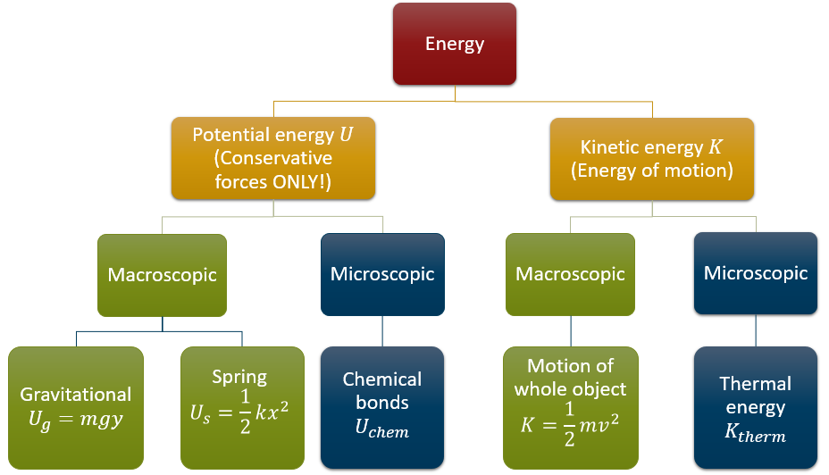

***FIGURE:*** *The different types of energy classified as microscopic and macroscopic*